**The Audio Programmers**

**SERQET**

**Use Case Report**

***Revision History***

|  |  |  |  |  |
| --- | --- | --- | --- | --- |
| **Authors** | **Description of Change** | **Sections** | **Rev** | **Date** |
| Team | SERQET Created (new program in skeleton state) |  |  | 1-30-19 |
| Robert | Created basic sine wave oscillator |  |  | 2-6-19 |
| Robert | added dsp library (Maximillian library) |  |  | 2-11-19 |
| Robert/Elias | implemented saw wave function, removed Maximillian library oscillator |  |  | 2-12-19 |
| Robert | Added comments for readability |  |  | 2-13-19 |
| James | Added low pass filter |  |  | 2-18-19 |
| Alex | Implemented slider and slider behavior skeleton |  |  | 2-25-19 |
| James | Added ladder filter |  |  | 3-4-19 |
| Robert | MIDI event implementation |  |  | 3-13-19 |
| Alex | Readjusted layout and added completed filter section |  |  | 3-15-19 |
| James | Fixes to MIDI implementation |  |  | 3-18-19 |
| Alex | Additional UI elements for added effects |  |  | 4-15-19 |
| Elias | Fixed issues with multiple keyboard notes held down |  |  | 4-19-19 |
| Robert | Removed if statement that was blocking external keyboards |  |  | 4-20-19 |
| James | Made effects parameters work |  |  | 4-22-19 |
| James | Added delay, reverb, and master volume |  |  | 4-24-19 |
| Elias | Improved note memory capability |  |  | 4-24-19 |
| James | Polished delay |  |  | 4-29-19 |

**Table of Contents**

1 Team Description 4

2 Project Description 4

2.1 Use Case Diagram 5

2.2 Use Case List 6

2.2.1 Load/Save 6

2.2.2 Edit Settings 6

2.2.3 Revert Settings 6

2.2.4 Produce Audio 7

# Team Description

|  |  |
| --- | --- |
| **Team Member Name** | **Email Address** |
| Alexander Feldman | feldman0007@csu.fullerton.edu |
| James Dobson | bobberino98@csu.fullerton.edu |
| Elias Jackson | eliasthemusician@csu.fullerton.edu |
| Robert Rivas | r_rivas@csu.fullerton.edu |

# Project Description

*Statement of Purpose:*

We are programmers with a passion for music, so what better way to exercise our passion than creating software that provides us with greater control over sound at its source. By creating an audio application that processes audio in whatever manner we choose, we have greater flexibility to create sounds that are fine-tuned to our liking.

SERQET is an audio processing application that will accept MIDI input from the user to control the pitch of the oscillators in a synthesizer. MIDI (Musical Instrument Digital Interface) is a standard protocol for communicating musical information in digital music production. The synthesizer will be a playable instrument, intuitively designed, with a suite of effects to enhance the sound.

*Detailed Description of SERQET:*

Our application will consist of a simple GUI interface with various buttons, knobs, and sliders that will allow users to customize the sound to their liking. Our program will process the MIDI input, using it to control the synthesizer, and then modify the output sound with effects. Effects will include reverb, delay, distortion, etc, in order to give the user the widest array of sounds possible. The user will also be able to change the waveform of the oscillators, and use filters to alter the sound of the oscillators.

## 

## 

## Use Case Diagram

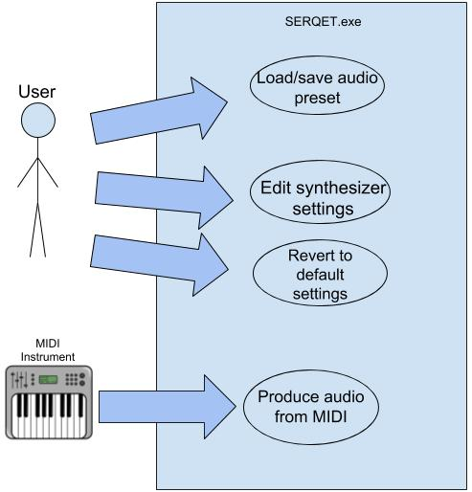

## Use Case List

|  |  |  |
| --- | --- | --- |
| **Use Case** | | |
| **Sequence Number** | **Actor** | **Goal** |
| 1 | User | Load/Save audio preset |
| 2 | User | Edit synthesizer settings |
| 3 | User | Revert to default audio settings |
| 4 | MIDI Instrument(operated by user) | Process audio from MIDI |

### <Load/Save>

Primary Actor: User

Goal in Context: Load/Save an audio preset that will be applied to the oscillator.

Preconditions: Load: A file containing audio presets must exist

Additional Description: At any point while running the application the user can choose to save or load presets. If audio settings have been altered from the default state, the user will be prompted whether they would like to save their current settings before loading a preset.

### <Edit Settings>

Primary Actor: User

Goal in Context: Modify synthesizer settings

Additional Description: User can select from a suite of effects and filters to enhance the sound, as well as the option to alter waveform shape and volume.

### <Revert Settings>

Primary Actor: User

Secondary Actors(s): None

Goal in Context: Revert to default audio settings

Preconditions: Audio settings not at default

#### 

### <Produce Audio>

Primary Actor: MIDI Instrument

Secondary Actors(s): None

Goal in Context: Produce audio from a MIDI input

Additional Description: MIDI can be sourced from an input device such as a keyboard, or from a file loaded into an external Digital Audio Workstation.